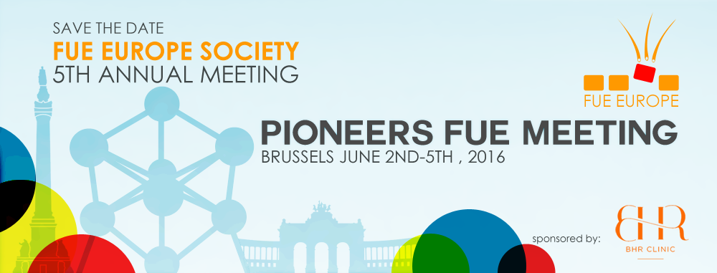
SPEAKERS AND THEMES
PLEASE SUBMIT A TOPIC OF YOUR PRESENTATION BASED ON THE THEMES (Maximum of two presentations)

SURGEON NAME | Donor Management , PRP and New Therapy | FUE complications and limitations | FUE techniques and tools | Body Hair | Business and others

 | Abstract of Scientific Study | Abstract on a Position | Abstract of a Surgical Video | Abstract on a Case for Live Patient Viewing
Type of Abstract (Select one)

Name of Author
Summary of Abstract (2 Paragraphs Maximum)
Author Biography (1 Paragraph)
Any specific requirement?

PLEASE SEND THE FORM TO FUE EUROPE AT : FUE2016@BHRCLINIC.COM

